**SCRIPT OF MALAYALAM**

**https://24x7offshoring.com/**

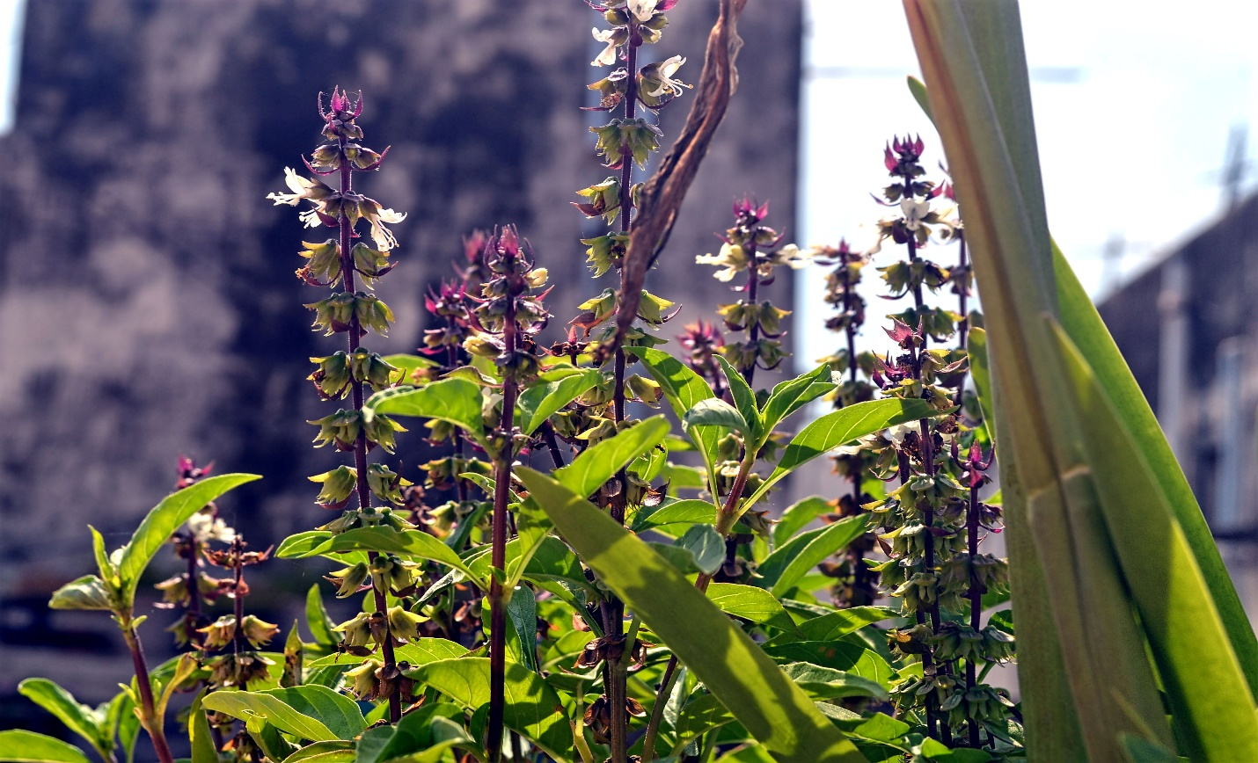 [**http://24x7outsourcing.com/**](http://24x7outsourcing.com/)

**Malayalam Writing System**

Verifiably, a few contents were utilized to compose Malayalam.

Among these contents were Vattezhuthu, Kolezhuthu and Malayanma contents. Be that as it may, it was the Grantha content, another Southern Brahmi variety, which led to the cutting edge Malayalam content.

It is syllabic as in the arrangement of realistic components implies that syllables must be perused as units, however in this framework the components addressing singular vowels and consonants are generally promptly recognizable.

Malayalam content comprises of a sum of 578 characters. The content contains 52 letters including 16 vowels and 36 consonants, which structures 576 syllabic characters, and contains two extra diacritic characters named anusvāra and visarga. The prior way of composing has been supplanted by another style starting at 1981.

This new content lessens the various letters for typesetting from 900 to less than 90. This was mostly done to remember Malayalam for the consoles of typewriters and PCs.

In 1999 a gathering named "Rachana Akshara Vedi" created a bunch of free text styles containing the whole character collection of in excess of 900 glyphs.

This was reported and delivered alongside a content tool around the same time at Thiruvananthapuram, the capital of Kerala. In 2004, the text styles were delivered under the GNU GPL permit by Richard Stallman of the Free Software Foundation at the Cochin University of Science and Technology in Kochi, Kerala.

Malayalam has been written in different contents like Roman and in a sort of Arabic content; Arabic contents especially were instructed in madrasahs in Kerala and the Lakshadweep Islands.

**Malayalam Script**

It is acknowledged that the high level Malayalam content created from 'Grandha' content which is generally called 'Arya ezhuthu'. 'Vattezhuthu' was the substance used to record Malayalam before the Grandha content was gotten for the explanation. The substance called 'Kolezhuthu' and ' Malayanma' were moreover used for the most part.

From seventh century AD onwards, 'Grandhaksharam', the Grandha content, was used to create Sanskrit. The Pallava rulers, who administered from the city at Kanchipuram, pushed Grandha content since the Tamil letter sets were not satisfactory to record the Sanskrit language.

This new substance after a short time spread to Kerala too. During the standard of Pandya and Vijayanagara domains, western Grandha content made in the Malabar locale and an eastern Grandha content variation made in the Tamil Nadu territory.

The western Grandha content grew continually to shape substance of Dravidian lingos like Tulu and Malayalam.

'Vattezhuthu' which had no suctioned consonants was not sensible to interpret Sanskrit books. This incited the Grandha content obtaining value. As a response for this lacunae Ezhuthachan, the father of Malayalam Language, made another social event of letter sets in Malayalam by modifying the Grandha content. Regardless, it can't be unquestionably said that Ezhuthachan made the Malayalam letters all together.

For, as shown by the acclaimed grammarian A. R. Raja Varma, the Tulu language moreover used comparable substance and along these lines this get-together of letters all together was insinuated as "Tulu Malayalam Aksharamala'.

The Grandha content created from Brahmi which was an outdated Indian substance. The development and satisfaction of the current day Malayalam content is obliged to the 'Grandha' content.

The setback of consonants in 'Vattezhuthu', 'Kolezhuthu' and 'Malayanma' substance that were required to make Sanskrit incited the improvement of the present-day Malayalam content from 'Grandha' content.

**SCRIPT OF MALAYALAM**

**https://24x7offshoring.com/**

**http://24x7outsourcing.com/**